TOKYO CHALLENGE 2020
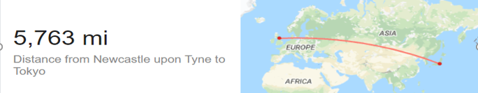
Record your miles covered between 23rd July and 8th August.
Then message your overall score to the Northumberland School Games Facebook page.
Will the people of Northumberland get there?
Family Members
23rd July
24th
25th
26th
27th
28th
29th
30th
31st
1st
2nd
3rd
4th
5th
6th
7th
8th (Final day*)
Individual Totals
Overall family total miles.

Can only measure your steps? 2,000 steps = 1 mile; 10,000 steps = 5miles
Don’t forget to have your own closing ceremony and send your pictures to Northumberland School Games Facebook page!

